Mini Project #2
Business Requirement
The analytics environment must support descriptive analytics for enterprise reporting, diagnostic analytics to identify performance bottlenecks across systems, and predictive analytics integrated with machine learning workflows. The data warehouse must structure business data into dimensional models that support efficient reporting across time, department, product, and operational metrics. Dashboards must provide business stakeholders with KPI visibility, system performance metrics, operational insights, and predictive outputs generated by ML models. The platform must support SQL-based reporting, data visualization tools, and interactive BI dashboards. The system must also enable exploratory data analysis and feature engineering workflows for data scientists using scalable compute environments.
Deliverables:
- Type of analytics (Descriptive, Diagnostic, Predictive)
- Data warehouse schema (Star schema example)
- BI tool design (QuickSight / Power BI equivalent)
- Sample dashboard mockup
Output:
- Dashboard wireframe
- Explanation of business KPIs

Step 1 — Identify Datasets
Dataset Name | Dataset Fields
Transactional Records | Transaction_ID, Transaction_Date, Store_ID, Customer_ID, Product_ID, Quantity, Unit_Price, Total_Amount, Payment_Method, Promotion_ID
Customer Interactions | Interaction_ID, Customer_ID, Channel, Interaction_Date, Interaction_Type, Resolution_Status, Sentiment_Score, Agent_ID, Duration_Minutes, Follow_Up_Required
Operational Logs | Log_ID, System_ID, Log_Date, Event_Type, Severity_Level, Component, Error_Code, Resolution_Time, Impacted_Service, Status
Analytical Datasets | Trend_ID, Industry_Sector, Trend_Date, Product_Category, Market_Demand_Index, Competitor_Price_Index, Economic_Index, Seasonality_Factor, Customer_Sentiment_Score, Forecast_Demand_Growth
Customer Profiles | Customer_ID, Customer_Name, Customer_Segment, Age_Group, Gender, City, Signup_Date, Preferred_Channel, Loyalty_Status, Total_Lifetime_Value
Product Catalog | Product_ID, Product_Name, Category, Sub_Category, Unit_Cost, List_Price, Launch_Date, Supplier_ID, Status, SKU
Sales Opportunities | Opportunity_ID, Customer_ID, Product_ID, Opportunity_Source, Opportunity_Date, Opportunity_Status, Estimated_Value, Sales_Representative, Campaign_ID, Close_Date
Inventory / Stock Levels | Product_ID, Warehouse_ID, Stock_Date, Stock_On_Hand, Reorder_Level, Reorder_Quantity, Supplier_ID, Inventory_Status, Lead_Time_Days, Last_Updated
ML Feature Store | Feature_ID, Model_Name, Feature_Name, Feature_Value, Feature_Date, Entity_ID, Entity_Type, Version, Is_Active, Last_Computed

Step 2 — Identify Types of Analytics
Analytics Type | Analytical Question | Related Datasets
Descriptive Analytics | What departments and product lines produce the most transactions and revenue, and what are the customer interaction distribution patterns across service channels? | Transactional Records, Customer Profiles, Customer Interactions, Product Catalog
Diagnostic Analytics | What operational bottlenecks, pattern of system failures, and customer lifecycle events contribute to revenue leakage and falling customer lifetime value? | Operational Logs, Sales Opportunities, Customer Interactions, Customer Profiles, Inventory/Stock Levels
Predictive Analytics | Which product categories and customer segments are most vulnerable to demand shortfall in the next quarter based on historical trends in transaction and engineered ML features? | ML Feature Store, Transactional Records, Sales Opportunities, Customer Profiles

Step 3 — Identify Key Business KPI
Analytical Question | Dataset | KPI | Aggregation Function
Which departments and product lines are generating highest volume and how are interactions distributed? | Transactional Records | Total Revenue by Product Category | SUM
 | Transactional Records | Transaction Volume by Department | COUNT
 | Customer Interactions | Interaction Rate by Service Channel | COUNT
 | Customer Profiles | Active Customer Rate by Segment | COUNT
What are the bottlenecks and lifecycle events that are causing revenue leakage and declining CLV? | Operational Logs | System Downtime Frequency by Component | COUNT
 | Sales Opportunities | Opportunity-to-Close Conversion Rate | AVG
 | Customer Interactions | Average Resolution Time by Issue Type | AVG
 | Customer Profiles | Customer Churn Rate by Loyalty Tier | AVG
 | Inventory / Stock Levels | Total Inventory Available | SUM
 | Inventory / Stock Levels | Average Reorder Quantity | AVG
Which segments are at highest risk of demand shortfall next quarter? | ML Feature Store | Churn Prediction Score by Customer Segment | AVG
 | Sales Opportunities | Forecasted Pipeline Value by Quarter | SUM
 | Transactional Records | Repeat Purchase Rate by Product Line | AVG

Step 4 — Design the Data cleaning / Data summarization
Zone | Structure  (Folders, Datasets) | Justification
Raw Zone | operational_systems_raw | Preserves transactional records and operational logs in original format for traceability and audit compliance
 | business_applications_raw | Retains customer interactions, sales opportunities, and customer profiles without modification as ingested from source systems
 | external_sources_raw | Stores third-party market intelligence and industry trend data in its original structure before any transformation
Cleaned Zone | transactional_records_clean | Removes duplicate transactions, standardizes date formats, validates Product_ID and Customer_ID, fills null Unit_Price with category average
 | customer_profiles_clean | Removes duplication of customer records by Customer_ID, normalizes City and Segment values, Loyalty_Status values are validated against defined categories.
 | analytical_datasets_clean | Checks Trend_Date formats, removes null Market_Demand_Index or Forecast_Demand_Growth values, normalizes Product_Category names, removes duplicates in Trend_ID.
 | product_catalog_clean | Removes Product_ID duplicates, validates List_Price and Unit_Cost are not zero, normalizes category and sub category naming, removes SKUs with no valid Supplier_ID, and makes Launch_Date formatting consistent.
 | customer_interactions_clean | Normalizes Interaction_Type and Channel fields, removes records with no valid Customer_ID, standardizes Resolution_Status values
 | operational_logs_clean | Filters noise-level system events, standardizes Severity_Level classification, removes incomplete log entries, missing Event_Type or Component.
 | inventory_stock_levels_clean | Validates Stock_On_Hand against Reorder_Level thresholds, removes expired stock records, standardizes Inventory_Status flags.
 | sales_opportunities_clean | Validates Opportunity_Status values, standardizes Estimated_Value currency format.
Curated Zone | enterprise_reporting_dataset | Aggregates cleaned transactional and customer data into department and product-level summaries to support descriptive KPIs and executive dashboards
 | customer_segmentation_dataset | Combines customer profiles, interaction history, and opportunity data to support churn rate, CLV, and segment-level analysis for diagnostic KPIs
 | demand_forecast_dataset | Joins inventory and historical transactions to produce demand index and forecast accuracy metrics for predictive KPIs
 | ml_feature_store_dataset | Aggregates engineered features from transactional, customer datasets to feed SageMaker ML model training and churn prediction pipelines

Step 5 — Design (Data Analytics Platform)
Dataset | Type
Transactional Records  Analytical Datasets  Customer Profiles  Product Catalog  Sales Opportunities  Inventory / Stock Levels  ML Feature Store | Structured
Operational Logs | Semi-structured
Customer Interactions | Unstructured

Dataset | Name: inventory_stock_levels  PK (Primary Key) Field: product_id  FK (Foreign Keu) Field: warehouse_id, supplier_id  Non-Key Field: product_name, category, stock_date, stock_on_hand, reorder_level, reorder_quantity, inventory_status  Numeric Fields: stock_on_hand, reorder_level, reorder_quantity  Categorical Feilds: category, inventory_status, supplier_id, warehouse_id
EDA | Outlier: 0%  Missing values: 0%  Duplicated values: 0%
Descriptive Analysis | What is the inventory status and stock levels of all product categories and warehouses?
Diagnostic Analysis | Why are certain product categories frequently falling below their reorder levels?
Predictive Analysis | What is the estimated stocks level of each product category next month?
Prescriptive Analysis | What reorder quantities should be recommended per product to prevent stockouts and reduce excess inventory?

Step 6 — Implementation (Screenshot)
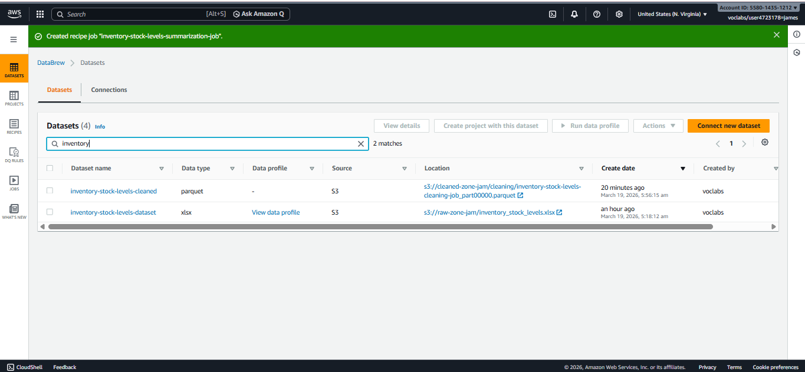
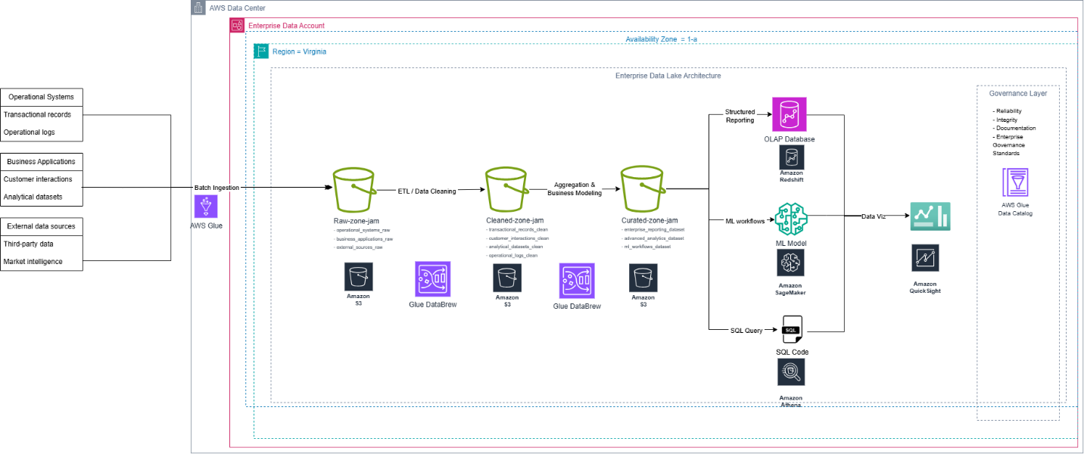
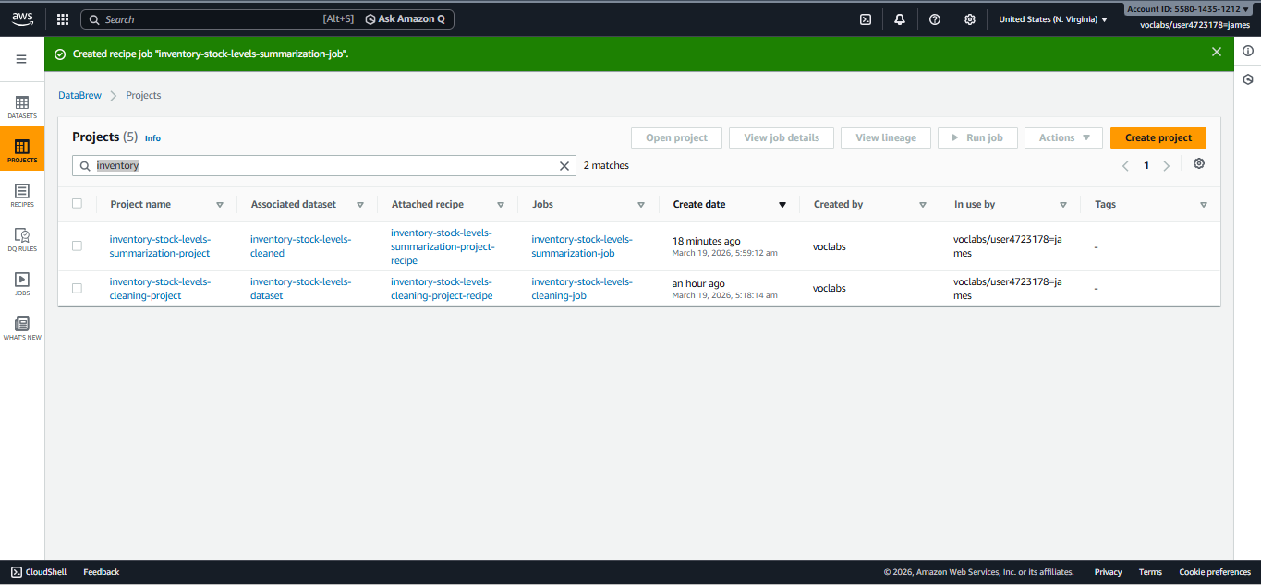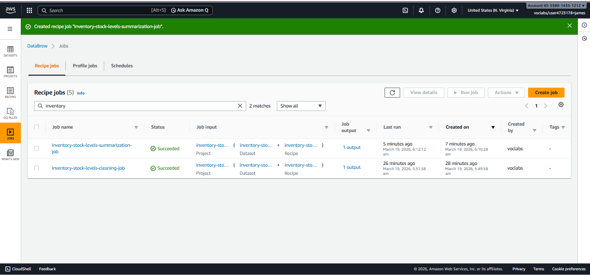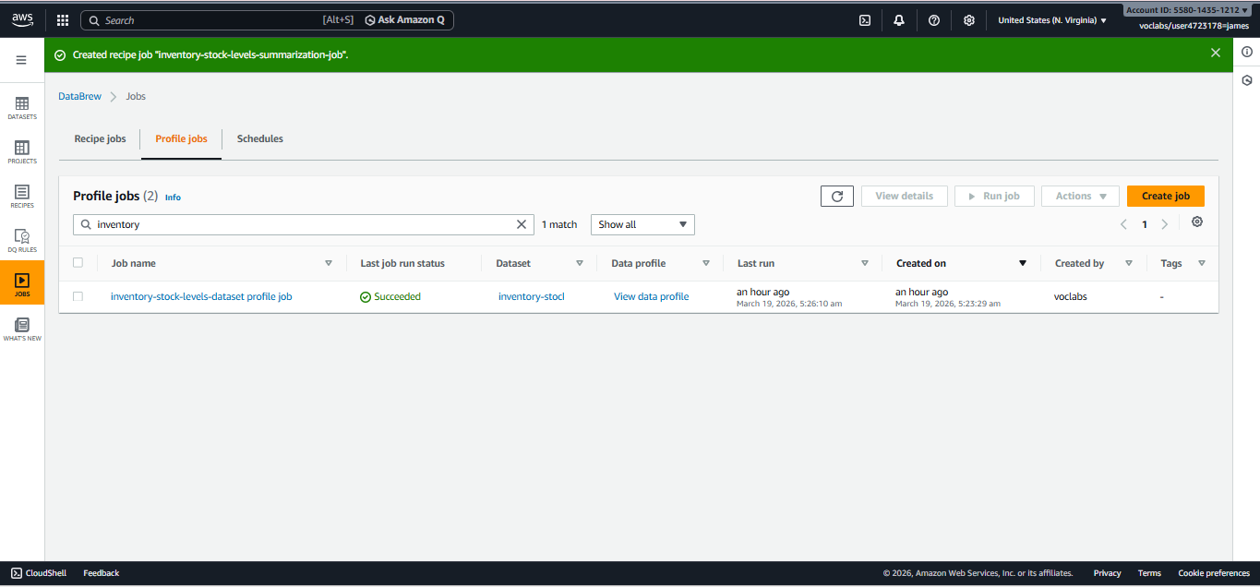

KPI 1: Total Inventory Available (SUM of Stock_On_Hand)
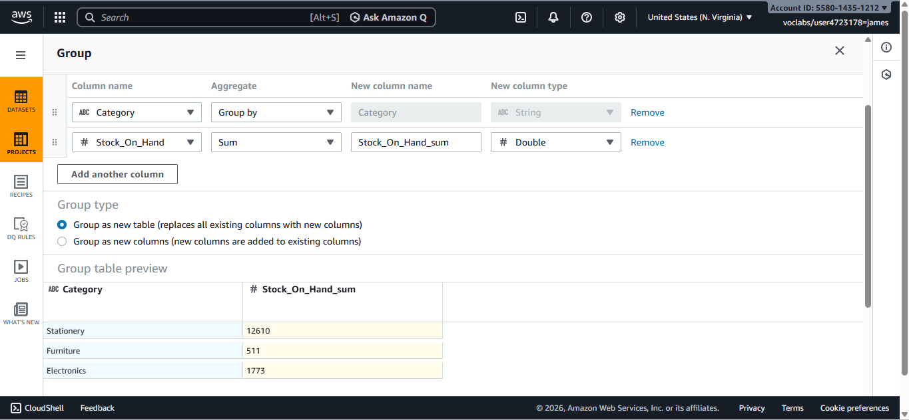

KPI 2: Average Reorder Quantity (AVG of Reorder_Quantity)
